**SEIS752 Advanced Web Design**

**Spring 2015**

**Project Report**

**‘Vacation Planner’**

**Mike Palmer & John Stark**

**Table of Contents**

# Introduction

# Description

## Purpose

## List of web pages

## More stuff

# Technologies employed

## Languages (Html, javascript, php, JSON…).

## External API’s (Google maps)

## Database (MySQL, tables created)

## IDE

## Site Host (dreamer42 … , XAMPP – LocalHost, )

# Scope

## In-scope

## Out-of-scope

## If We Had More Time We Would …

# Software Development Process

## Agile

## Start small, code a little- test a lot

# Technical challenges encountered

1. **Introduction**

This project provided an opportunity to apply the lessons learned during the course and to develop an application to a greater extent that was possible in the weekly homework assignments.

1. **Description**

## purpose

This project developed and deployed a website for recording vacation plans. The user enters their daily itinerary and then references it during their travels. It provides a convenient means to save important information such as reservations, confirmation numbers, phone numbers and email addresses for lodging, sites to visit, daily destinations, etc.

## List of webpages.

The user interacts with some 11 webpages

* Home page / index - register or log-in
* Welcome page with options to:
  + CreateNewVacation 🡪 createNewVacationPlan
  + Work with existing vacation plans 🡪 listOfVacations
* VacationSummary

## More Stuff maybe a viso type diagram

# Technologies employed

## Languages (Html, javascript, php, JSON…).

Type some text

Google Map API (see below)

Bootstrap

Had build in resizing, formatting, colored buttons,…

Bootbox

Modal message boxes built on bootstrap and jQuery

Query parameters ….

better security and special characters

Login using encryption and SALT for storing password.

## External API’s (Google maps)

We used the Google Map API in our website. Our integration provides the user with a map showing their travel route, and computes their travel distances.

## Database (MySQL, tables created)

We used MySQL with is part of XAMPP

## IDE

Type some text

## Site Host (dreamer42 … , XAMPP – LocalHost, )

Type some text

# Scope

## In-scope

Type some text

## Out-of-scope

Type some text

## If We Had More Time We Would …

Type some text

# Software Development Process

## Agile

Type some text

## Start small, code a little- test a lot

Type some text

# Technical challenges encountered

Type some text

NetBeans IDE did not always show errors, Chrome Inspector was better at this

Bootstrap versions were not forward/backward compatible.

Javascript is very picky and not informative about errors

**SEIS 752 – Final Project Proposal**

**Team Members:**

* Mike Palmer
* John Stark

**Project Description:**

The website resulting from this project will provide a traveler with a way to organize their travel plans. Users will be able to create vacation itineraries. This will help them during the planning process as they assemble the pieces. It will also be a helpful tool on the vacation to reference reservation numbers and chart the progress of their trip.

**Key Features:**

Create User Account

User Login

Create New Vacation

Display Vacation

Update Existing Vacation

Delete Vacation

Store Core Information about Each Day

**Bonus Features:**

Store Addition Advanced Information

Calculate Mileage Traveled Each Day

Provide a Map Showing Route

Provide Reports about Trips

Color Code Vacation to Alert to Areas of Concern

Security Measures Beyond Basic Login

Polished UI

**User Stories:**

#1 - planning

User wants to plan a vacation. User enters each day into the system. Fills in starting city, ending city, main activity for the day, and lodging info.

#2 – vacationing

User references the app each day. Retrieves their hotel reservation info. Reviews the activities for the upcoming day.

**Mock-up of Possible Screen**

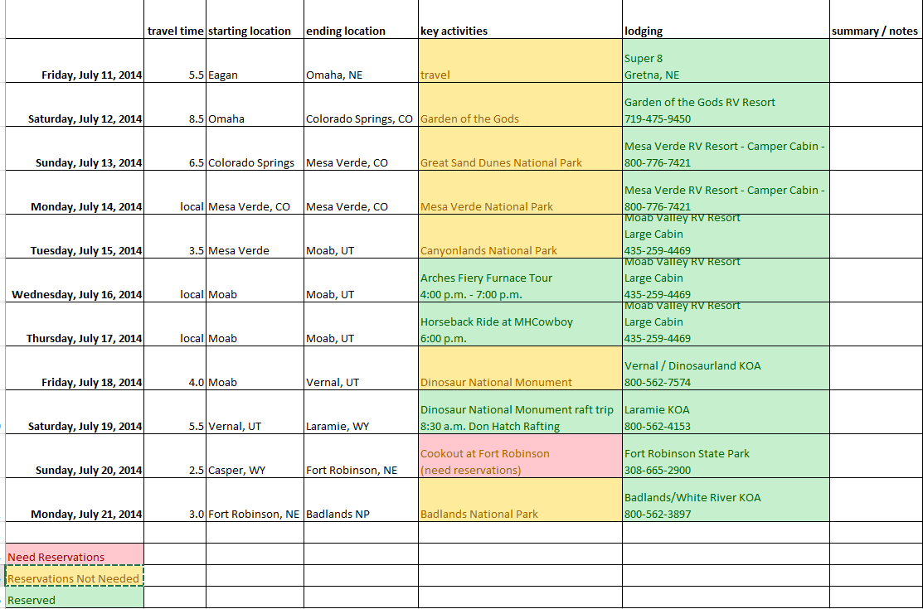

**Challenges**

Using an external API to calculate travel time between two cites by driving.

Ensuring data is validated.

Preventing security breaches.

**Project Timeline**

|  |  |  |
| --- | --- | --- |
| Event | Start Date | End Date |
| Prepare Proposal | 2/18/2015 | 3/4/2015 |
| Gather Additional Requirements | 2/25/2015 | 3/11/2015 |
| Database Table Created | 3/11/2015 | 3/18/2015 |
| Login Screen | 3/11/2015 | 3/18/2015 |
| Display Single Vacation Day | 3/11/2015 | 3/25/2015 |
| Display Multiple Vacation Days | 3/11/2015 | 4/1/2015 |
| Entry of Single Vacation Day | 4/1/2015 | 4/8/2015 |
| Entry of Multiple Vacation Days | 4/1/2015 | 4/15/2015 |
| Add, Update, Delete | 4/8/2015 | 4/22/2015 |
| Bonus Features | 4/15/2015 | 5/6/2015 |
| Testing & Fixing | 4/15/2015 | 5/12/2015 |
| Launch! |  | 5/13/2015 |

**Tentative Technology Plan**

LAMP stack

GIT

MySQL

HTML

PHP

Javascript

NOTES PASTE THINGS BELOW HERE THAT WE NEED TO INCLUDE IN THE REPORT

THIS IS JUST A SCRATCH PAD FOR OUR NOTES

Should technologies employed look like

This list shows up to 3 instances of where used

* Php
  + fetchVacationRow.php
  + insertVacation.php
  + deleteVacationPlan.php
* javascript
  + index.php
  + vacationSummary.php
  + setDayDetails.php

Screen shots of pages

